New technologies in photovoltaic technology: electrical energy production from vertical walls
F. Viola, P. Romano, A. Busacca

Dipartimento di Energia, ingegneria dell’Informazione e modelli Matematici, DEIM, University of Palermo, Italy

Abstract— In this article the preliminary evaluation of the performance of a photovoltaic window is presented. The aim is to trace the behavior of next-generation systems, which favor architectonical integration. Three different systems have been taken into account: a dye sensitized solar cell (DSSC), blue and grey caved silicon panels. The systems can be placed behind a window or behind a wall of glass blocks.
Keywords- green energy; integrated photovoltaic, DSSC.

Introduction
In the recent years buildings account for about 40% of world CO₂ emissions, mainly due to their air conditioning, heating and electricity systems. Therefore, renewable energy use and performance optimization in buildings are critical to fight climate change. Several efforts have been addressed towards the reduction of building consumption, improving the performance of the building envelope, without giving up on building aesthetics and at sustainable costs (e.g. using novel building materials, integrated generation heat and electric devices).
Actually, new photovoltaic technologies, aimed at making solar cells cheaper than the traditional photovoltaic (PV) and with better architectural integration, are developed. Among these innovative technologies, referred as third PV generation, solar cells based on semiconductors, which have a nano-crystalline structure, in which hybrid organic–inorganic dyes, able to absorb sunlight, seem the most promising. These cells are identified as DSSC from the acronym dye-sensitized solar cell [1].The possibility of using cells of different colors and various degrees of transparency offers a high potential for architecturally integrated applications [2]. Furthermore, DSSC modules can be indeed bifacial devices, able to convert efficiently into electricity the light coming from both outside and indoor environments.
The traditional systems, however, are far to be left in favor of new-generation systems, in fact, a particular evolution of silicon panels can be used in the generation that uses as a support glass of windows: systems in which the silicon is dug to ensure the transparency of the support have been developed.
The aim of this paper is to evaluate the performance of the systems and trace-out the economic advantages of the use of the new technologies.

Structures
The first structure under study is vertical glass wall. For this structure three different generation systems have been developed: the first one is a DSSC and the other two are silicon dug panels. Figure 1 shows systems under study.

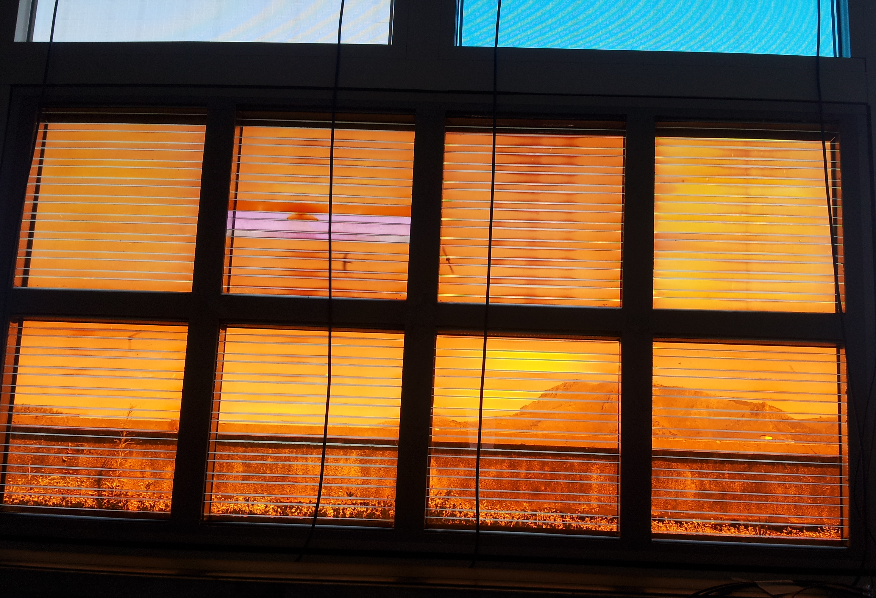
- Particular of the PV wall, DSSC has an orange color dye, laminated silicon systems are grey and blue.
Windows with integrated PV systems have been settled with dimensions 1200 mm x 600 mm; DSSC has a eight sub-panels, laminated silicon panels are not subdivided, their transparency degree varies from dark (opaque) to a conventional 40%.
The sub-panels of DSSC have been connected in series. By considering a morning in which the irradiance was 709 W/m² for horizontal plane, in the vertical system the open circuit voltage reaches 20 V, and the short circuit current 0.3A.
Figure 2 and 3 show the voltage-current and voltage-power profiles.

- Voltage-current profile of the DSSC vertical system.

- Voltage-power profile of the DSSC vertical system.
The technique used to make the transparent silicon is to dig the laminations, removing the active material, so as the degree of transparency increases, the cells are more and more emptied of electrical sources. Data sheets suggest that maximum power of a windows varies from 45 Wp to 20 Wp depending on the degree of transparency. Open circuit voltage has a constant value 58 V, only current varies with transparency short circuit current varies from 1.07 A to 0.54A. The vertical placement reduces the estimated values.
Figures 4 and 5 show the performance of the grey silicon in the vertical wall.

- Voltage-current profile of the grey silicon vertical system.

- Voltage-power profile of the grey silicon vertical system.

Figures 6 and 7 show the performance of the blue silicon in the vertical wall.

- Voltage-current profile of the blue silicon vertical system.

- Voltage-power profile of the blue silicon vertical system.

It is possible to evaluate the efficiency of the vertical walls, on horizontal surface the incoming power is 709W/m², panels have a surface of 0.72 m², in such a way the efficiency is 0.31% for DSSC and 1.37% for the silicon panels.
The low efficiency has to be related to the vertical inclination of panels, which reduces the efficiency to 10% of the best azimuth placement.
During the day, presented power values vary, but for the economic balance are taken those reported here.

GLASS BLOCK WALL
Figure 8 shows the glass block and internal PV structure. DSSC or silicon is fixed in the surface facing the internal environment, in order to protect and maintain it.
The structure can be imagined as composed of two shells of transparent glass, held together by a frame opaque. The glass structure has the task of ensuring the mechanical function of the system, but also to present the best passage to the light radiation, it must therefore be assumed flat surfaces and not corrugated. The possibilities of DSSC integration into the glass block have been studied and deeply discussed in previous works [2-3].
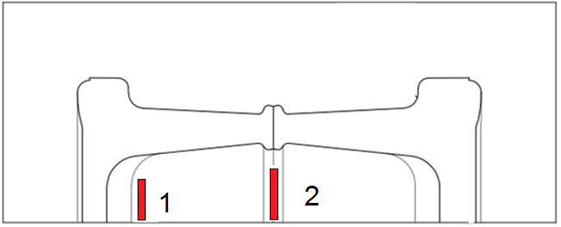
- Section of the glass block in which thePV cell is red coloured: 1 internal placement on the surface, 2 in the middle section.
In [3] is reported the characterization of the shaded areas in the glass block. By taking into account the radiation in free space and beyond the glass block an average in order of 10% reduction can be evaluated, as shown in figure 9.
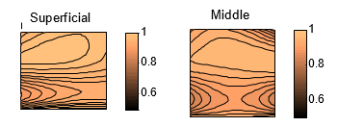
- Distributions of daylight in the surface of the glass block, referred to the free space.

Cost of systems
Costs of the two PV types are different and depend on the complexity of the used processes. Several factors affect the final cost, especially the difficulty and the number of operations. The process of construction of a DSSC is undoubtedly less complicated because the operations to be carried out are simpler and fewer in number and, at the same time, the energy required for hot working is much lower. The only process that requires a heating of the material is the sintering process, while the creation of a silicon cell high temperatures are required by the processes of purification, doping, and deposition of the anti-reflective coating. Moreover, what makes the process more complex is the need for an extremely clean inside the working environment, because the process of silicon purification must be done perfectly to avoid abrupt efficiency declines due to the presence of impurities.
The production technologies required for DSSC are, however, now fully developed in other industrial sectors, so there are no established technologies and energy-efficient process that allow reducing the payback time for any investment.
Data on the cost of production of DSSC are not easily found in the literature. Researchers in [5] have estimated production costs for DSSC cells are respectively: 2.2 $ / Wp (DSSC Mayer) and 0.8 $ / Wp (Smestad). The most interesting for our case study is the cost per m², estimated at 64 $/ m² (58.9 €/m²) for Smestad or 110.6 $/ m ² (101.7 € / m²) for the DSSC of Mayer, prices calculated with the current exchange rate. Mayer suggest an efficiency of 5% for the DSSC, Smestad of 15%.
The considered production cost of a polycrystalline silicon cell is of $ 1.78 / Wp and 267$/$m^{2}$ (245,5€/$m^{2}$) and it is been considered also for the laminated cell.
As we can notice, the production costs of the cells DSSC are lower, and this confirms that the processes that lead to its realization are undoubtedly less complex than those for a cell of silicon.

Comparative analysis of systems
For quantitative analysis, a 1.5kWp wall has been taken into account. We consider both the technical data found in literature, both the values experimentally obtained. For the comparison between DSSC, the Mayer cell has been considered, for silicon panel an opaque panel has been taken into account.
Table 1 shows the costs of vertical integrated systems. The cheaper systems is the one created with opaque silicon panel, which cannot be used for a window. Interesting performance is given by the Mayer cell, which cost is near to the traditional opaque panel. Not brilliant performances have been shown by monitored systems, for which efficiency is far from the theoretical.
The use of a glass wall cement slightly increases the costs for the realization of the system.

Table 1
 | Technical literature |  | Experimental
 | DSSC | Silicon | DSSC | Grey | Blue
Efficiency | 5% | 15%
Vertical | 2.5% | 7.5% | 0.31% | 1.31% | 1.31%
Surface [m²] | 40 | 13.3 | 322.6 | 76.6 | 76.6
Cost [€] | 4068 | 3273 | 32806 | 18740 | 18740
Glassblock [€] | 4520 | # | 36452 | 20823 | 20823

Economic evaluation of investments in real case: external staircase cover
The cost and efficiency of an external staircase with generating vertical walls, which realizes the access to a house two families, with average annual consumption of 9000kWh, has been considered. The coverage of the scale described will take the form of a parallelepiped, of which sides and roof surface have to be established in order to evaluate the quantity of cells needed and the cost. To determine the lateral surface we use the measures of the scale, adding the measure gaps between scale and coverage, so the two sides surface is 71.46 m²; the other side surface is 42,35 $m^{2}$, the roof surface has an area equal to 18.03 m². The total area and the result is 131.84 m².
Determined the total area of the wall to be produced, our aim will be to calculate the price of the construction of the wall in glass bricks, on which we will assume to apply two types of cells: DSSC (Mayer), ordinary silicon cells, and experimental DSSC and blue and gray laminated silicon. The calculations do not consider different exposure to solar radiation during the hours of the day.
First, we determine the cost of only glass block common to both DSSC covers. A single glass block is the size of 19x19x8 cm, then to form 1 m² of the wall, so 25 pieces are needed. The price of double glass block wall with clear surface is € 202.54/m², the purchase price includes materials and labor. The total cost of only glass blocks will therefore be about € 26,700.

For the south Italy installation an average daily energy of 1.5 kW / m² is considered (hypothesis advantageous).
- External staircase cover.
From the qualitative point of view, since the case study is the coverage of an outer scale, the aesthetic point of view that the different types of technology allow to obtain, has to be analyzed. The cell DSSC manage to integrate perfectly with the structure as it has transparency and various colors. The silicon cell, in contrast, is completely black and without any transparency, completely obscuring the scale of cover and making the structure not very pleasant to the sight. Laminated silicon panels allow an architectonically integration with the structure. Although the choice of cells DSSC seems the most advantageous from the point of view of aesthetics, DSSC cells have the upper limit of energy produced due to the lower efficiency; in the case of energetic nature constraint, the only solution would be the use of silicon cells.
In table 2 a comparative analysis for with the evaluation of the net present value has been made. Initially the Mayer’s DSSC and a silicon panels has been considered, and it is referred to them as technical literature model, then the analysis with the experimental cell has performed.
The ten years are taken to the life duration of DSSC and also for the silicon panels, which can last for twenty years, but a common duration is required for the analysis. Cost are the same for theoretical and experimental systems, only the efficiency differs. No incentive plan has taken.
The cost of glass block cover has been removed. By considering Mayer’s DSSC, the energy produced is not able to cover the required demand, so annually energy has to be taken from the grid. Only the system based on silicon panels is able to support the demand.
The economic analysis shows that the first two systems have a negative net present values, so investments is not convenient. In the case of silicon panels used for twenty years, the NPV can became positive, but such choice is not suggested by architectonical point of view.
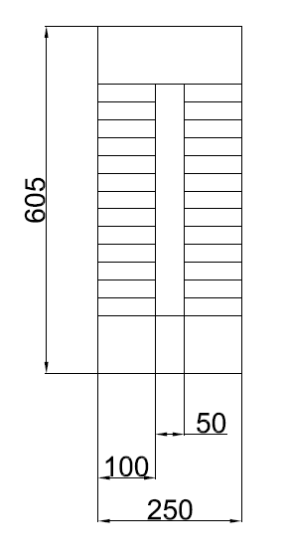
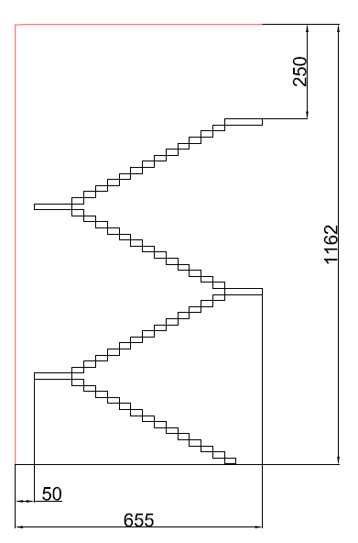
By considering the experimental systems, the energy made in the first year, which is the most productive, is so negligible that the NPV is quite the cost of the system.
Table 2
 | Technical literature |  | Experimental
 | DSSC | Silicon | DSSC | Grey | Blue
Vertical efficiency | 2.5% | 7.5% | 0.31% | 1.31% | 1.31%
Annual decay | 5% | 0.5% | 5% | 0.5% | 0.5%
Life Years | 10 | 10+ | 10 | 10+ | 10+
Cost €/m² | 101.7 | 245.5 | 101.7 | 245.5 | 245.5
Cost [€] | 13409 | 32367 | 13409 | 32367 | 32367
Power [kW] | 9.89 | 29.6 | 1.22 | 5.17 | 5.17
first year energy [kwh[ | 6279 | 18839 | 778 | 3290 | 3290
Energy required [kWh] | 9000 | 9000 | 9000 | 9000 | 9000
First year E sold [kWh] | -2721 | 9839 | -8222 | -5709 | -5709
NPV | -11498 | -15164 | -13000 | -30000 | -30000

The obtained results show that none of the investments, considered without incentives, it is convenient. DSSC, both Mayer’s suggested and experimental ones, get an initial better result only for their lower purchase cost, but fail to meet the need for energy due to the low efficiency of the cells used in the vertical position. For silicon cells, however, the efficiency is always low, able to meet the demand for energy only with traditional silicon panels, but with a high cost of the plant.
Such non performing results are justified by the fact that, as mentioned before, the DSSC cells are still under development and not available in the market. The investment in traditional silicon cells, widely spread in the market, fails in architectonical integration, but not in the requirement of energy; on the contrary, the laminated cells, not able to guarantee energy requirements but with a duration of twenty years, are the next to be chosen to develop vertical generating walls, as soon as their efficiency will be close to that of the cells not excavated.

Conclusion
In this paper, a comparison between the costs of vertical wall has been traced. Vertical transparent walls, made with DSSC and laminated silicon cells, show costs greater than a traditional vertical PV systems, suggesting that better technologies have to be developed in order to perform a competitive answer to already used technologies.

References
- O’Reagan, B., Grätzel, M., “A low-cost, high-efficiency solar cell based on dye-sensitized colloidal TiO2 films”, in Nature353, 737 - 740 (24 October 1991); doi:10.1038/353737a0.
- Kalyanasundaram, K., Ed., Dye-sensitized solar cells, EPFL Press, Lausanne, ISBN: 978-2-940222-36-0.
- Corrao, R., Morini, M., “Integration of Dye-Sensitized Solar Cells with Glassblock”, in CZASOPISMO TECHNICZNE, Issue 3, Year 109, p. 55-64, ISSN: 0011-4561.
- Viola, F ; Romano, P; Miceli, R; Riva Sanseverino, E; Corrao, R; Morini, M; Pastore. L; Pidanic, J; Perrone, G, Performance of the Glass Block in Photovoltaic Generation, 2015 Tenth International Conference on Ecological Vehicles and Renewable Energies (EVER), Monaco Ever 2015
- Joseph Kalowekamo , Erin Baker , “Estimating the manufacturing cost of purely organic solar cells”, Volume 83, Issue 8, August 2009, Pages 1224–1231, doi:10.1016/j.solener.2009.02.003

